Press release
30 June, 2008
HIAB XS 111 and Volvo FL6 – The ultimate combination

When Johan Bergk thought about acquiring a new works vehicle his requirements seemed almost impossible. He needed a strong crane for heavy lifts and jobs with a clamshell bucket but, at the same time, wanted it fitted onto a small lightweight truck – a Volvo FL6. However, a most suitable solution was found – a HIAB XS 111 HiDuo.

Johan Bergk, who drives for Allservice in Stav, has a wide range of jobs at Stockholms Entreprenad – from helping to lay tarmac, handling gravel, soil, sand and loads of brushwood as well as clearing up and putting things in order.
– Earlier I used a Volvo FM9 fitted with a HIAB 135, but the truck was too big. In this field of work, lots of jobs involve driving on cycle tracks and parkways and it's a bit of a squeeze at times. When we suggested downsizing everything Johan was doubtful – but he was pleasantly surprised by the result.
– The truck is just great for the types of jobs I do. The versatility of the HIAB XS 111 E-4 HiDuo means I hardly notice any differences compared to before and it has the advantage of taking up less of the total load capacity. In fact, I can load 300 kg more on this smaller vehicle than the one I had earlier!
This capacity is needed, since he frequently handles heavy loads. From time to time he has to fill all of the children's sandpits with fresh sand – that means a really full load.
– The wet sand lifts are heavy, with lots of bucket work. But my 111 crane has the capacity to do the work quickly.
Clearly there is a solution to solve the equation “smaller truck plus lighter crane gives higher payload capacity and crane output”.
As Johan Bergk sums up – HIAB 111 is the ultimate crane for the Volvo FL6. It gives the greatest possible capacity for such a small truck.

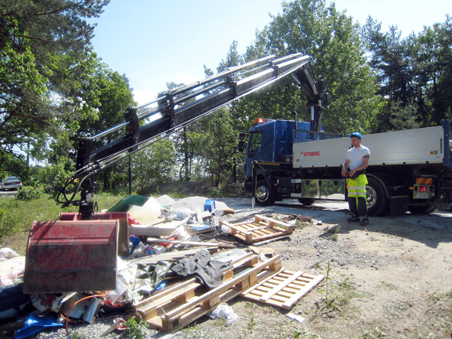
(HIAB_111E-4.jpg)
Clearing up parks in Stockholm is part of Johan Bergk's work. There’s a lot of rubbish to be handled from time to time, but using a HIAB XS 111 E-4 HiDuo speeds things up.


(111E-4_Johan_Bergk.jpg)
The same power, a lighter, smaller truck, and higher payload capacity. Johan Bergk won in every way when he changed vehicle and crane.

Hiab is the world’s leading supplier of on-road load handling equipment. The product range includes HIAB loader cranes, LOGLIFT and JONSERED forestry and recycling cranes, MULTILIFT demountables, ZEPRO, FOCOLIFT, AMA and WALTCO tail lifts, as well as MOFFETT and PRINCETON PIGGY BACK® truck-mounted forklifts.
In 2007 Hiab’s net sales totalled EUR 931 million, it delivered nearly 60,000 load handling units and employed 4,400 people. Hiab operates globally and has production facilities in 10 countries, including China, Estonia, Finland, Ireland, the Netherlands, Poland, South Korea, Spain, Sweden and the United States. The company has sales companies and representative offices in 31 countries as well as independent importers and distributors in 100 countries around the world.
Hiab is part of Cargotec Corporation. Cargotec is the world’s leading provider of cargo handling solutions whose products are used in the different stages of material flow in ships, ports, terminals, distribution centres and local transportation. Cargotec Corporation’s brands, Hiab, Kalmar and MacGREGOR, are market leaders in their fields and well-known among customers all over the world. Cargotec’s net sales are EUR 3 billion. The company employs over 11,000 people and operates in close to 160 countries. Cargotec’s class B shares are quoted on the OMX Nordic Exchange Helsinki.
www.hiab.com

Further information is available from:
Göran Wiklund, Press Liaison Officer
Tel. ++46 650 91168
Email goran.wiklund@hiab.com

The descriptions and data contained in this press release apply to the specified Hiab models. Product specifications and availability may vary from country to country and change without notice.

