Press release
30 June, 2008
Klas juggles concrete blocks

Concrete piles and concrete blocks. Kurt Hedins Åkeri AB, a haulier in Södertälje, just south of Stockholm, has a niche handling long and heavy concrete items. The concrete blocks in question are primarily used in road construction work where they are laid out mile after mile, alongside work in progress, to keep traffic on the right side of workplaces. The piles are used in groundwork in the construction industry. For more than 40 years Hiab cranes have taken care of the heavy handling required by Kurt Hedin’s customers.

– My first crane was a HIAB ”Elefant” 173 with chain attachments. I particularly remember when parking it on cold and frosty mornings – I had to pull it together by hand! If anyone had shown me then what loader cranes would be like today I'd have thought they were joking. But you get used to things quickly says Kurt Hedin.
Nowadays it's his son Klas who drives a truck, fitted with their latest crane – a HIAB XS
477 EP-5 HiPro, serving a trailer, 17.7 metres long and with steerable axles.
– Concrete piles are usually eight metres long, so I can load the truck with double rows of them. They can be as long as 13 metres which, of course, isn't a problem at all, says Klas Hedin. Their haulage firm currently runs six Scania trucks, five fitted with customized cranes: a HIAB 330, a 400, an XS 422, an XS 477 EP-5 as well as a 4-axled Scania 164 with a HIAB XS 288 HiPro and a Multilift demountable.
– We can load 30 tons on the small truck and equally as much on the long trailer. This capacity is needed as each concrete block weighs two tons. Placing them at the back of the long trailer isn't a problem using our 477 EP-5. This gives the lifting power that's needed and some to spare.
– Everything's getting bigger and bigger, so the resources are needed. When it comes to piles I often have to lift them over obstacles and down into building foundations. But there aren't any problems. This crane manages more than two-ton loads even when fully extended – 15.4 metres. We've had it a year now and it works like a dream all the time, says Klas Hedin.

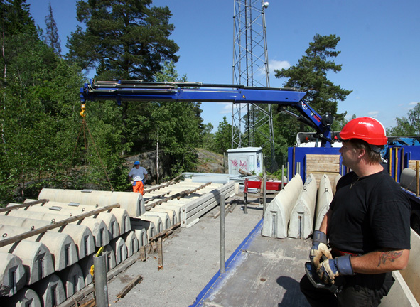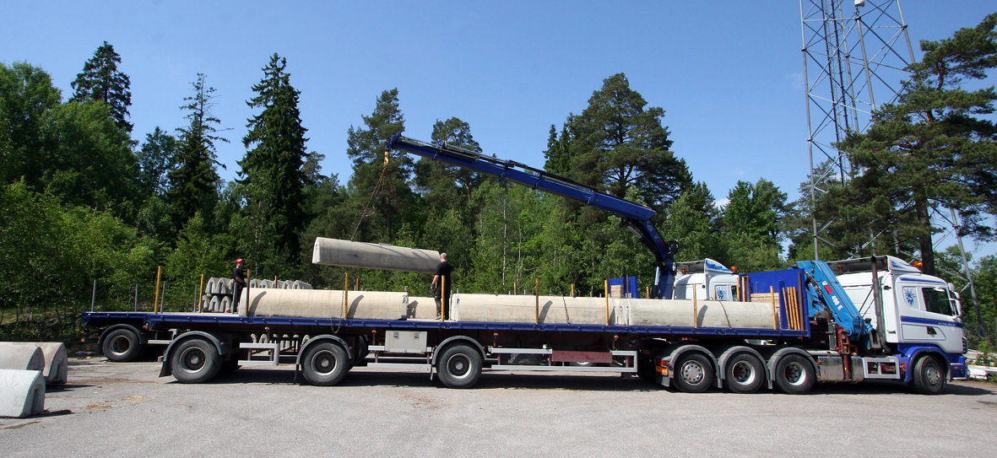
(477_Klas_Hedin_Loading_road_barriers.jpg) (477_Long_loading.jpg)
Klas Hedin handling one of many loads of concrete road barriers to keep traffic away from road construction workers.
– With our HIAB 477 EP-5 HiPro we have all the power we need. It’s always worked like a dream and is perfect for tricky situations, like lifting piles over obstacles and down into foundations, Klas tells us.


(477Kurt+Klas.jpg)
Klas continues in his father’s footsteps. For over 40 years Kurt Hedin has used HIAB cranes in his business .
– The first one was a HIAB 173 fitted with chains. If anyone had shown me then what loader cranes would be like today I'd have thought they were joking, says Kurt.

Hiab is the world’s leading supplier of on-road load handling equipment. The product range includes HIAB loader cranes, LOGLIFT and JONSERED forestry and recycling cranes, MULTILIFT demountables, ZEPRO, FOCOLIFT, AMA and WALTCO tail lifts, as well as MOFFETT and PRINCETON PIGGY BACK® truck-mounted forklifts.
In 2007 Hiab’s net sales totalled EUR 931 million, it delivered nearly 60,000 load handling units and employed 4,400 people. Hiab operates globally and has production facilities in 10 countries, including China, Estonia, Finland, Ireland, the Netherlands, Poland, South Korea, Spain, Sweden and the United States. The company has sales companies and representative offices in 31 countries as well as independent importers and distributors in 100 countries around the world.
Hiab is part of Cargotec Corporation. Cargotec is the world’s leading provider of cargo handling solutions whose products are used in the different stages of material flow in ships, ports, terminals, distribution centres and local transportation. Cargotec Corporation’s brands, Hiab, Kalmar and MacGREGOR, are market leaders in their fields and well-known among customers all over the world. Cargotec’s net sales are EUR 3 billion. The company employs over 11,000 people and operates in close to 160 countries. Cargotec’s class B shares are quoted on the OMX Nordic Exchange Helsinki.
www.hiab.com

Further information is available from:
Göran Wiklund, Press Liaison Officer
Tel. ++46 650 91168
Email goran.wiklund@hiab.com

The descriptions and data contained in this press release apply to the specified Hiab model. Product specifications and availability may vary from country to country and change without notice.

